

**Assessment Report**

on

**“Classify Students Based on Study Methods”**

submitted as partial fulfillment for the award of

**BACHELOR OF TECHNOLOGY**

**DEGREE**

SESSION 2024-25

in

**CSE(AI)**

By

Name : Aditya Kumar Singh

Roll Number : 202401100300016

Section: A

**Under the supervision of**

“BIKKI SIR”

**KIET Group of Institutions, Ghaziabad**

**April, 2025**

**1. Introduction**

Learning styles play a crucial role in determining how effectively a student grasps educational content. The three primary styles—visual, auditory, and kinesthetic—help educators understand student preferences and tailor instruction accordingly. With the advent of machine learning, clustering techniques can be used to classify students into learning style groups based on questionnaire responses.

**2. Problem Statement**

Traditional methods of identifying learning styles are often manual and subjective. There is a need for an automated, data-driven approach to classify students based on their preferred study methods. This can improve the personalization of educational experiences.

**3. Objectives**

* To use student responses on visual, auditory, and kinesthetic scores to identify learning style clusters.
* To apply K-Means clustering for classification.
* To visualize and analyze the resulting clusters.

**4. Methodology**

We adopted an unsupervised learning approach using the K-Means clustering algorithm. The methodology includes:

1. Loading the dataset.
2. Standardizing the feature values.
3. Applying K-Means clustering.
4. Visualizing the clusters in 3D space.

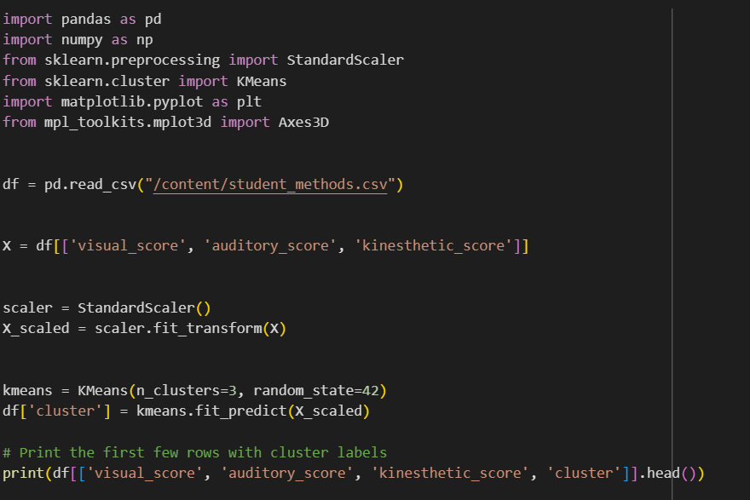

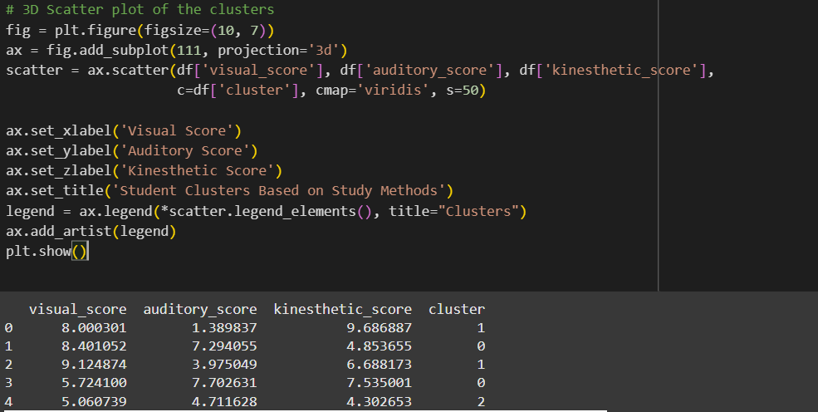

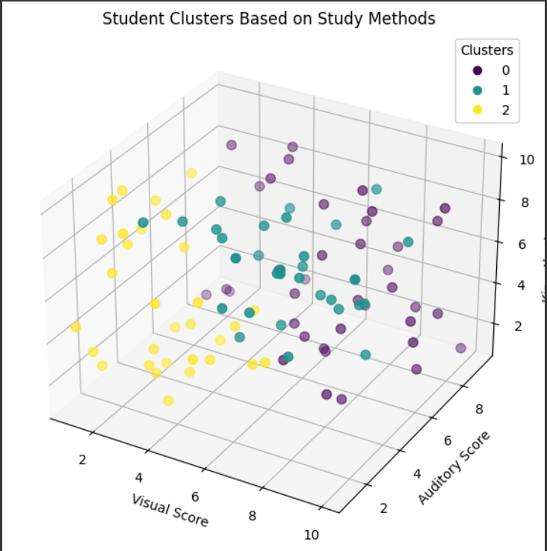

**5. Data Preprocessing**

* The dataset was read from a CSV file.
* The features visual_score, auditory_score, and kinesthetic_score were extracted.
* StandardScaler was used to normalize the data to ensure equal weight for each feature in the clustering process.

**6. Model Implementation**

* KMeans from scikit-learn was used with n_clusters=3.
* Each student was assigned to one of the three clusters.
* Cluster labels were added to the original dataset for further analysis.
* A 3D scatter plot was created to visualize clusters.

**7. Evaluation Metrics**

Since this is an unsupervised learning task, traditional accuracy metrics are not applicable. However, we evaluated clustering quality by:

* Observing the distribution of points in the 3D plot.
* Comparing clusters with the original learning_style column (if used).
* Inertia and silhouette score (optional metrics not included in this basic report).

**8. Results and Analysis**

* Three distinct clusters were formed based on the students' study method scores.
* Cluster interpretation:
  + Cluster 0: High auditory and moderate kinesthetic preferences.
  + Cluster 1: High visual and kinesthetic scores.
  + Cluster 2: Balanced or moderate scores.
* The visualization confirmed distinct groupings, suggesting that clustering aligns with natural divisions in study methods.

**9. Conclusion**

K-Means clustering successfully grouped students based on their study method scores. This approach offers an efficient, automated way to categorize learning styles, which can aid educators in customizing their teaching methods. Future work can involve validating clusters with labeled data or exploring other clustering techniques.

**10. References**

* Scikit-learn documentation: https://scikit-learn.org/
* Jupyter and Matplotlib documentation.
* Educational Psychology literature on learning styles.